Dostyk Advisory
Risk & Control … добавляя ценность

"Otbasy Bank" JSC

Review of the results of independent diagnostics of corporate governance

November 4, 2021

city of Almaty

Brief description of the project 3

Brief report on the work done 4

Main results of the assessment 5

Assessment of corporate governance by components 10

Conducting a seminar on the results of the services rendered 14

Annexes 15

Contact information 16

In accordance with paragraph 3 of article 182 of the Law of the Republic of Kazakhstan "On state property" (hereinafter referred to as the Law) imposes the requirement that joint-stock companies controlled by the state (with the exception of the national welfare Fund) are required to conduct an independent assessment of corporate governance at least once in three years, the results of which must be placed on the Internet resource of the company

Pursuant to the above provision of the Law, Dostyk Advisory LLP conducted an Independent Assessment of the corporate governance of Otbasy Bank JSC (hereinafter referred to as the Bank) as of October 31, 2021 in accordance with the terms of the Contract for the Purchase of Consulting Services in the Field of Corporate Governance No. 15-2021/502 dated July 23, 2021 on the basis of the Protocol on Results No. 36949-2-DATED July 12, 2021

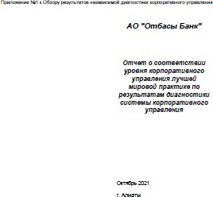Based on the results of the corporate governance assessment of Dostyk Advisory LLP, the following are presented:
- This review of the results of an independent assessment of the corporate governance system
- of Otbasy Bank JSC in the form of a presentation in MS Power Point format (hereinafter referred to as
the Review);
- Report on compliance of the corporate governance level with the best world practice based on the results of diagnostics of the corporate governance system at Otbasy Bank JSC (hereinafter referred to as the Report), Annex No. 1 to the Review in MS Excel and Adobe PDF format;
- Action plan for improving the corporate governance system of JSC
Otbasy Bank (hereinafter referred to as the Action Plan), Annex No. 2 to the Review in MS Excel and Adobe PDF format.

155 documents have been viewed
Internal documents have been viewed

Interviews with Bank officials were conducted

115 criteria evaluated

The data obtained were analyzed, the key strengths of the Bank were identified, and the current state of corporate governance was assessed
5 interviews with officials were conducted

An action plan and recommendations for improving corporate governance have been developed
6 recommendations have been prepared

Main results of the assessment
Summary of components

Compliance of the corporate governance level with the requirements of Otbasy Bank JSC with the best practice as of October 31, is 94.9%
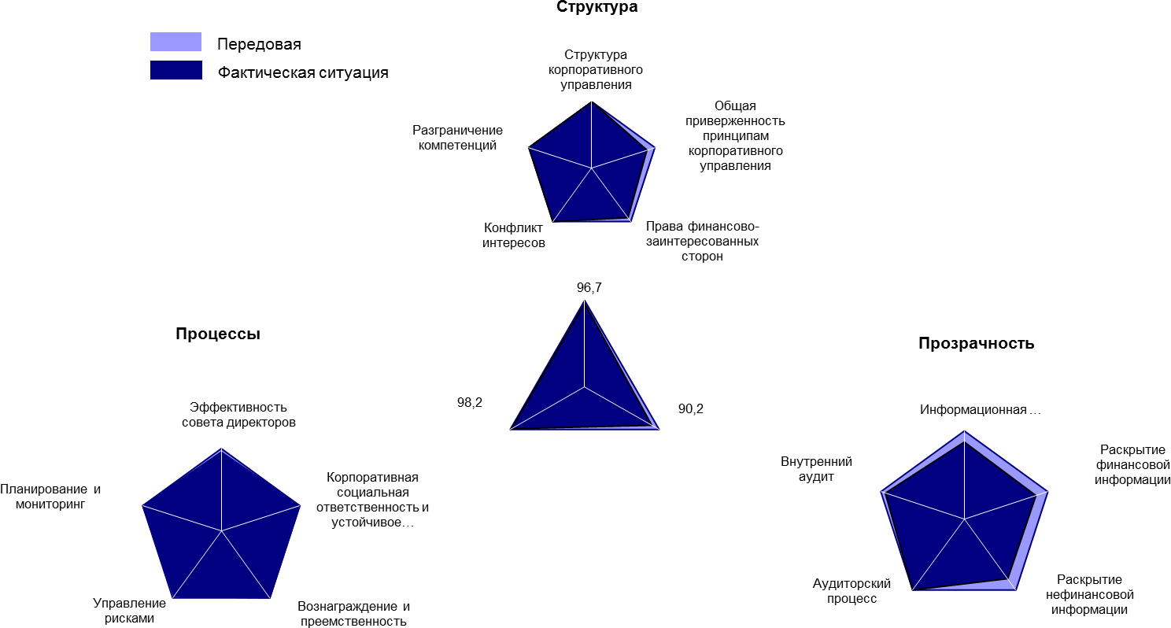

Main results of the assessment
Comparison with the previous assessment of the internal audit department

Name of the section | Percentage of compliance 2021 | Percentage of compliance 2019
1. Structure | 96.7 | 95.0
Corporate governance structure | 100.0 | 95.0
Overall commitment to corporate governance principles | 87.5 | 93.8
Rights of Financially Interested Parties | 92.9 | 92.9
Conflict of interest | 100.0 | 95.0
Differentiation of competencies | 100.0 | 100.0
2. Processes | 98.2 | 95.2
Effectiveness of the Board of Directors | 95.8 | 100.0
Corporate social responsibility and sustainable development | 100.0 | 95.0
Remuneration and succession | 100.0 | 78.6
Risk management | 97.5 | 100.0
Planning and monitoring | 100.0 | 96.9
3. Transparency | 90.2 | 95.1
Information policy | 87.5 | 93.8
Disclosure of financial information | 85.7 | 96.4
Disclosure of non-financial information | 84.1 | 93.2
Audit process | 100.0 | 100.0
Internal audit | 94.6 | 94.6
Final assessment | 94.9 | 95.1

Main results of the assessment
Criteria evaluation statistics

Conformity assessment | Structure | Processes | Transparency | Total
In progress | 26 | 39 | 31 | 96
Rather executed | 4 | 1 | 6 | 11
Partially executed | 0 | 1 | 2 | 3
Rather not executed | 0 | 0 | 2 | 2
Not being executed | 0 | 0 | 0 | 0
Not applicable | 2 | 1 | 0 | 3
TOTAL | 32 | 42 | 41 | 115

A total of 18 inconsistencies were identified according to 16 criteria, a total of 6 recommendations
There are no recommendations for 10 criteria, for the reasons indicated in the following table

Criterion number | Abbreviated description of the discrepancy | Reasons why recommendations are not provided
1.2.2 | 7. According to Paragraph 11 of Chapter 6 of the Corporate Governance Code of the Bank, the Ombudsman is obliged at least once a year to submit a report on the results of his work to the HR Committee, Remuneration and Social Benefits Committee and the Audit Committee of the Board of Directors, which assess the results of his activities. According to the information of the Corporate Secretary, as well as according to the analysis of the minutes of meetings of the Board of Directors of the Bank for 2019 - 2020, there is no data on the Ombudsman's report. At the moment, a new Ombudsman has been appointed in accordance with Protocol No. 9 dated September 6, 2021. | A new Ombudsman has been appointed in accordance with Protocol No. 9 dated September 6, 2021. According to paragraph 73 of the Corporate Governance Code of the Bank, the Ombudsman is obliged to submit a report on the results of the work carried out at least once a year to the HR Committee, Remuneration and Social Benefits Committee and the Audit Committee of the Board of Directors, which assess the results of its activities. The appointed Ombudsman acts on the basis of the Corporate Governance Code, in particular, the requirements for the activities of the Ombudsman are fulfilled in accordance with the Corporate Governance Code
1.3.3 | 4. According to the Procurement Plan for 2020-2021, 26 percent and 20 percent of purchases, respectively, were and will be organized by the tender method. The Bank's purchases in the form of an open tender are carried out in less than 50% of the total number of purchases in 2020-2021 for the following reasons:  - recognition of purchases by the tender method as failed;  - complexity or specificity of purchased goods, works, services;  - lack of market/offers. | External factors that are not directly dependent on the Bank.
1.3.5 | 2. Independent appraisers are not involved on the basis of an open tender. The services of independent appraisers are purchased using a single source method according to the Procurement Plan for 2019 - 2021, due to the limited number of suppliers meeting the requirements of the technical specification. | External factors that are not directly dependent on the Bank.
2.1.2 | 4. 1) The procedure for professional development by members of the Board of Directors is absent in the Regulations on the Board of Directors. Clause107 of the Regulations on the Board of Directors, which previously regulated the right of members of the Board of Directors to improve their qualifications within the funds provided for by the Bank's budget for the corresponding year, was deleted in accordance with the decision of the Sole Shareholder dated December 23, 2020 (Minutes No. 61/20).  2) According to the interview conducted with the members of the Board of Directors, there are no expenses for training or advanced training of directors in the Bank's budget. For the continuous development of directors, members of the Board of Directors should be given the right to regularly improve their qualifications. | In connection with the exclusion from the "Model Regulations on the Board of Directors of a joint-stock company, more than fifty percent of whose shares are directly or indirectly owned by the joint-stock company "NMH "Baiterek" on the right of ownership or trust management, approved by the decision of the Board of JSC "NMH "Baiterek" dated September 25, 2018 No. 38/18, norms for determining the training needs of members of the Board of Directors pursuant to paragraph 4 of the Action Plan for the implementation of the recommendations of the Accounts Committee for Control over the Execution of the Republican Budget based on the results of the state audit of the effectiveness of the use of funds of the Republican Budget and assets of the quasi-public sector.

Number  criteria | Abbreviated description of the discrepancy | Reasons why recommendations are not provided  рекомендации
3.2.5 | 1. A detailed revenue forecast is not disclosed, as it contains confidential information | This information is confidential according to the List of protected information approved by the Board of Directors dated October 15, 2018 (protocol No. 12).
3.2.7 | 2-3. The report of the Management Board of the Bank on the results of activities for the reporting year is not publicly available or the annual report, the Report on the results of activities for the year is additional information and is prepared in addition to the financial statements. This form of reporting, along with the annual report, allows you to disclose those factors that influenced the results of financial and economic activity and, thereby, increase its transparency. | This information is confidential according to the List of protected information approved by the Board of Directors dated October 15, 2018 (protocol No. 12).
3.3.6 | 2. The individual remuneration amounts of the members of the Management Board are not disclosed in the public domain, since this information is confidential according to the List of Protected Information approved by the Board of Directors of the Bank dated October 15, 2018 (protocol  №12). | Based on the results of discussions with members of the Board of Directors for security reasons and the risks of illegal actions.
3.3.7 | 2. Individual amounts of remuneration of members of the Board of Directors are not disclosed in public access, since this information is confidential according to the List of protected Information approved by the Board of Directors of the Bank dated October 15, 2018 (protocol  №12). | Based on the results of discussions with members of the Board of Directors for security reasons and the risks of illegal actions.
3.3.11 | 1.-4. Information about the decisions of the Sole Shareholder, the Board of Directors is not disclosed on the Bank's website. | This information is confidential according to the List of protected information approved by the Board of Directors dated October 15, 2018 (protocol No. 12).
3.5.12 | There is no specialized software (information technology) for planning, resource management, data analysis, maintenance of work files, for tracking the implementation of recommendations, approval of working documentation. Information technologies are not used to promote the Internal Audit Department, including the internal website of the internal audit service and electronic news letters. According to an interview with the head of the internal audit department, there is no suitable software on the market with an optimal price / quality ratio. The purchase of such is impractical due to the reduction of expenses in the Bank and is considered by the Sole Shareholder of the Bank. The lack of specialized software does not negatively affect the activities of the internal audit department. | Pursuant to paragraph 4 of the Action Plan for the implementation of the recommendations of the Accounts Committee for Control over the Execution of the Republican Budget based on the results of the state audit of the effectiveness of the use of funds of the Republican Budget and assets of the quasi-public sector, it was decided to reduce the costs of automation of internal audit.

1. Structure
2. Processes
3. Transparency

1.2. Overall commitment to corporate governance principles
The following functions of the Corporate Secretary provided by the Methodology are not fixed in the Regulations on the Corporate Secretary:
- monitoring changes in legislation and trends in corporate governance and preparing an overview of these changes and trends to the Board of Directors;
- monitoring trends in corporate social responsibility and preparing an overview of such trends to the Board of Directors, as well as providing advice on the Bank's reporting on these issues.

Recommended:
  - To consider possibility of including the following functions in the functions of the Corporate secretary (clause 15 of the Regulation on the Corporate Secretary):
    - monitoring trends in corporate governance and preparing an overview of these developments and trends for the board of directors;
- monitoring trends in corporate social responsibility and preparing a review of such trends for the Board of Directors, as well as providing advice on the Bank's reporting on these issues, required by the Corporate Governance Diagnostic Methodology.

1. Structure
2. Processes
3. Transparency

2.4. Risk management

According to the results of the analysis of information on limits (risk appetite) for 2020, there is 1 violation of the limit in the context of the business process Taxes, Tax reporting. The report on realized risks for the 4th quarter of 2020 indicates the reason for the violation of the limit: according to the report on the review of the Bank's tax liabilities for 2017-2018 and 2019, the auditors, referring to the letter of the State Revenue Committee of the Ministry of Finance of the Republic of Kazakhstan No. 570477 dated September 20, 2019 and the fact that the position of the tax authorities regarding the determination of royalties has changed and become more aggressive, gave recommendations to the Bank to assess tax risks, in terms of additional accrual of CIT at the source of payment at the rate applicable to royalties (15%) and VAT for non–resident services for revision, addition, modifications, software configuration (Colvir Software Solutions Ltd), prior to a tax audit by the tax authorities.

Recommended:
  - fully comply with tolerance levels (limits) in relation to approved risk appetite components (metrics), in particular in the context of the business process "Taxes, tax reporting".

1. Structure
2. Processes
3. Transparency

3.1. Information policy

There is no auditor's report and notes to the financial statements in the annual reports.
The website does not contain information about the decisions of the Board of Directors of the Bank and the Sole Shareholder, as this information is confidential according to the List of protected information approved by the Board of Directors of the Bank dated October 15, 2018 (protocol No. 12).

Recommended:
  - Include the auditor's report and notes to the financial statements in the Bank's annual report on an annual basis.
  - disclose on the website or other public access an overview of the decisions of the Board of Directors of the Bank and
The sole shareholder.

1. Structure
2. Processes
3. Transparency
3.3. Disclosure of non-financial information

Information on the ownership/non-ownership by members of the Bank's Management Board of shares of suppliers and competitors of the Bank, as well as information on the citizenship of members of executive bodies, is not disclosed.

Recommended:
  - disclose in public access (website or annual report) information on the ownership /non-ownership by members of the Bank's Management Board of shares of suppliers and competitors of the Bank, as well as information on the citizenship of members of executive bodies.

3.5. Internal audit

Director of the internal audit department is not a certified specialist in the field of internal audit (CIA Certified Internal Auditor). Currently, the exams are in the process. The first part of the exam was passed in 2020, the second part in 2021, the third part is scheduled for 2022.

Recommended:
  - complete training as a Certified Internal Auditor (CIA -Certified Internal Auditor) for the head of internal audit department.

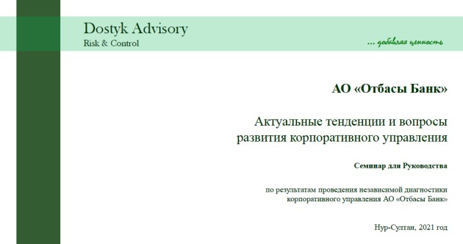Based on the results of the diagnostics, on November 12, 2021, Dostyk Advisory LLP held a seminar for the Management of Otbasy Bank JSC in an online format on the topic "Current trends and issues of corporate governance development".

Members of the Board of Directors, committees of the Board of Directors,
members of the Management Board, Directors of structural divisions were invited to the seminar.

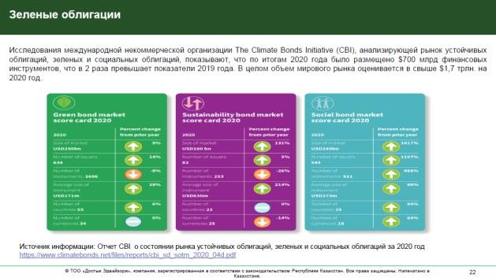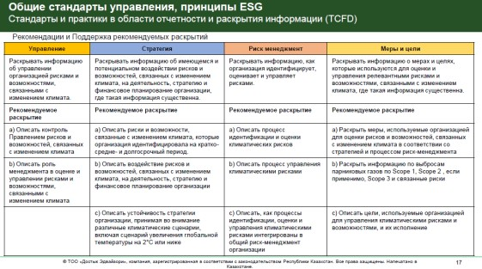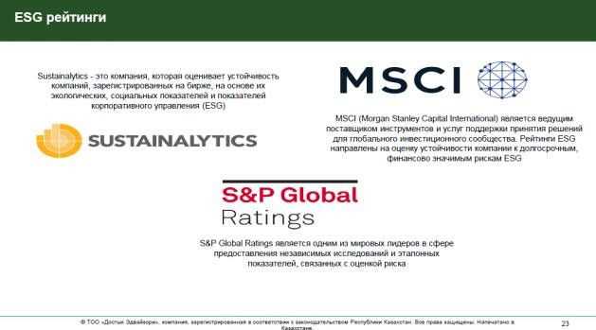Among the key topics of the seminar were reflected:
- Diagnostic results
- Basic principles of corporate governance:
  - OECD Principles;
  - Changes in the recommendations of the British Financial Reporting Council (FRC).
- Sustainable development issues:
  - General management standards, ESG principles;
  - Reporting and disclosure standards and practices;
  - Green bonds;
  - ESG Ratings.

- Annex No. 1 to the Review of the Results of the Independent Assessment of the "Otbasy Bank" JSC's Corporate Governance System.
Report on compliance of the corporate governance level with the best world practice based on the results of diagnostics of the corporate governance system in Otbasy Bank JSC (2. Evaluation Report Corporate Governance Department Otbasy Bank JSC.xlsm).
- Appendix No. 2 to the Review of the Results of the Independent Assessment of the "Otbasy Bank" JSC's Corporate Governance System.
Action plan for improving the corporate governance system of "Otbasy Bank" JSC
(3. The action plan of Corporate Governance Department Otbasy Bank JSC.xlsx).

Dostyk Advisory
Office in Nur-Sultan city
010000, the Republic of Kazakhstan, Nur-Sultan city, 12/1 Kunayev str., office 420
+7 (701) 701 757-00-51

office@dostykadvisory.com www.dostykadvisory.com

Kazakhstan company

